6. WELDING
WELDING: Welding is the process of joining two or more similar or dissimilar metals with or without the application of heat, with or without the application of pressure and with or without application of filler metal.
WELDING
FUSION |  |  | NON-FUSION OR PRESSURE
GAS | ARC | THERMIT WELDING | HOT | COLD

GAS
OXYACETYLENE | AIR ACETYLENE | OXYHYDROGEN | ATOMIC HYDROGEN

ARC
AC ARC WELDING | DC ARC WELDING |  | TIG WELDING | MIG WELDING | SAW
 | DCSP | DCRP

HOT
SOLDERING | BRAZING | BRAZE WELDING | RESISTANCE WELDING

RESISTANCE WELDING
SPOT WELDING | SEAM WELDING | PROJECTION WELDING | PERCUSSION WELDING
ADDITIONAL POINTS:
Preheating or Post heating | Weldability of metals | Defects in metals
FUSION WELDING: By meting the parent materials, if the joint is produced called as fusion welding operation.
It’s divided in to three types,
- Gas Welding: By burning of gases if the heat required for the melting of plate is obtained is called as gas welding.
- Arc Welding: By using electric arc if the heat is required for the melting of plate is obtained is called as arc welding operation.
- Chemical Welding: By using exothermic chemical reaction if the heat required for the melting of the plate is obtained is called as chemical welding operation.
NON-FUSION: Without melting of the parent material if the joint is produced called as non-fusion.
PRESSURE WELDING: With the application of pressure if the joint is produced called as pressure welding operation.
COLD PRESSURE: At room temperature, with the application of large amount of pressure if the joint is produced called as cold pressure welding operation.
CRYOGENIC: By cooling the metals to the temperature less than $-183°C$ and with application of large amount of pressure f the joint is produced called as cryogenic welding.
NOTE: Any system working at a temperature less than $-183°C$ is known as cryogenic system.
- OXY ACETYLENE GAS WELDING:
Acetylene (C2H2) Cylinder Oxygen (O2) Cylinder  LH Thread RH thread  Red/ Maroon Colour Black Colour  Rubber or Plastic Hose Cu hose  P = 15 KSC P = 120 KSC  Chemical Reactions:  $$C_{2}H_{2}+O_{2}⟶2CO+H_{2}+Heat$$ $$2CO+O_{2}⟶2CO_{2}+Heat$$ $$H_{2}+0.5O_{2}⟶H_{2}O+Heat$$ For complete combustion of $C_{2}H_{2}$ 2.5 Units of $O_{2}$ Required out of that 1 is taken form cylinder |  | 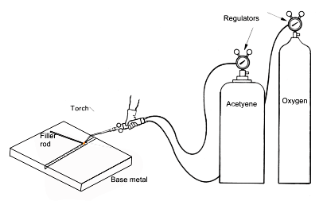
Based on the amout of oxygen taken from cylinder, the flame produced is divided into three types,
- Neutral Flame: The inner core is red or yellow where as the outer cone is light blue colour. When compared to the maximum temperature, the average temperature of the flame is reducing by 1/3rd . $O_{2}: C_{2}H_{2}=1:1$
$$T_{avg}=2000 to 2100 °C$$ | $$T_{max}=3260 °C$$ | $$N=10 to 15 mm$$
Application: This flame is used from cutting and joining of all the ferrous and non ferrous metals expect brass. During joining of brass work piece, the zinc present in the brass is getting evaporated and onl copper will be left over.
- Oxidizing Flame: The slightly lean mixture will always give the highest efficient efficiency of combustion. Hence, the miximum temperature in the process is increaseing. The flame should not be used for joining of highly reactive metals such as aluminum, magnesium etc…$O_{2}: C_{2}H_{2}=1.15 to 1.5$
$$T_{avg}=2100 to 2200 °C$$ | $$T_{max}=3380 °C$$ | $$N=N/3to N/2$$
Application: This flame will be used ofr joining of brass work piece. Because It forms oxides with highly reactive materials E.g. tenuous oxide (Zinc oxide).
- Reducing or Carburizing Flame: Heat loss by convection and radiation will be high.$O_{2}: C_{2}H_{2}=0.85 to 0.95$
$$T_{avg}=1800 to 1900 °C$$ | $$T_{max}=3040 °C$$ | $$N=2N to 3N$$
Application: It is most commonly used for joining of high carbon steels.
- In case of steels, which increase of carbon contenst with melting point of steel is reducing. Therefore high carbon steels will havve lower melting point.
- High carbon steels are already saturated with the carbon, hence even though free carbon is available in the flame, it cannot be absorbed by the high carbon steels.
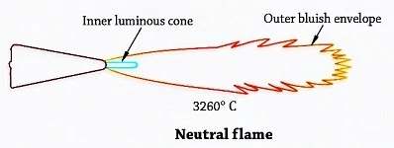 | 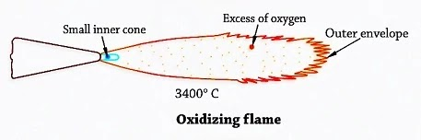 |  | 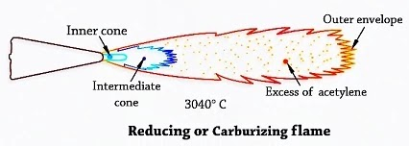
FLEXIBLE HOSE PIPE:
- The flexible hose pipe connected to a oxygen cylinder is made by using copper as a material so it has flexibility and can withstand higher pressure.
- The best pipe material for acetylene cylinder is rubber or plastic hose pipe which is cheaper and it can withstand lower pressure of acetylene.
- By mistakes if both pipes are interchanged, both the pipes will fail. Therefore, to avoid the interchangeability the difference between the cylinders such as size, colour and direction of threads can be used.
TORCH ANGLE: It’s the angle between axis of workpiece and axis of torch.
- Increasing in torch angle, the area of weld bead to which flame is exposing will be reducing.  - The heat supplied per unit exposing area of weld bead is called as flame density.  - For the given flame, heat supply rate remains constant, therefore as the torch angle increasing, the exposing area reducing and therefore the flame density is increasing. | $$Flame Density$$  $$=\frac{Heat Supply}{Exposing Area}$$
FACTORS INFLUENCING THE SELECTION OF TORCH ANGLE:

- Melting point of a metals to be joining.
- Thickness of metal plate must be joined.
- Thermal conductivity of metal.
- Place of welding.

WELDING TECHNIQUES:
- Forehand or left-hand welding Technique: Focus of the flame is toward non welded area.  Some slag particle will be retaining inside the weld bead and non-uniform slag layer is formed over the weld bead. The presence of slag inclusion reduces the strength of joint and non-uniform slag layer is promoting the atmospheric contamination.  - Backhand or Right welding Technique: Focus of the flame is toward welded area.  The force of flame is pushing out of molten slag particles and therefore no slag inclusion is present in the weld bead, therefore uniform slag layer is forming on the weld bead. | 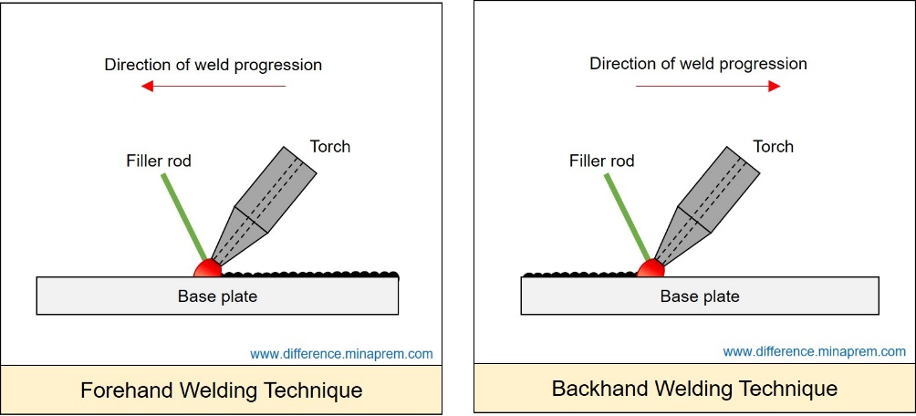  Forehand Welding

Horizontal Welding Position:
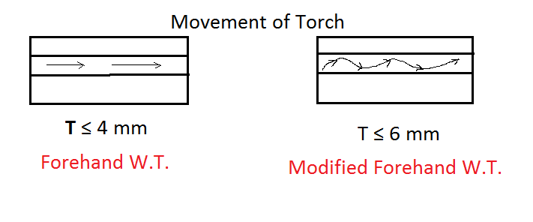 | 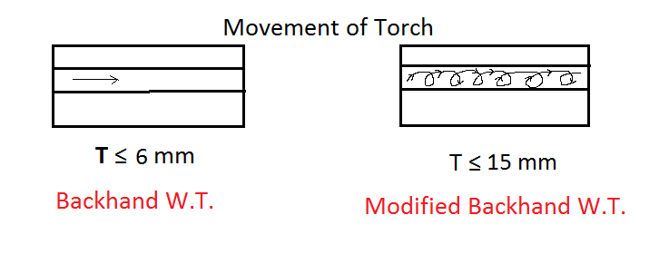
Vertical Welding Position:
In vertical welding position, the welding is always carried from bottom to the top so that already welded position is acting as obstruction for the flow of molten in downward direction. In addition, if forehand welding technique is used then it gives additional force for holding the molten metal particles. Hence, forehand welding is used.
Horizontal-Vertical Welding Position: Backhand Welding technique is used.
Overhead Welding Position: Backhand Welding technique is better because it gives additional force to hold molten metal particles. Here, surface tension property is more important in this case.
FLUS IN GAS WELDING:

- To deoxidize the melt.
- To absorb gases.
- To form a slag layer over the weld bead for protecting weld bead from atmosphere.

PROPERTIES OF FLUX:  - It can deoxidize the melt.  - It can absorb the gases present in molten metal.  - It can form the slag layer.  - It should have very low density.  - It’s melting point should be less then melting point of parent metal.  - It should not produce any harmful gases such as sulphur dioxides. | APPLICATIONS OF FLUX:  - During gas welding of carbon alloys or nickel alloys there is no flux required in welding process. Because it-self acts as deoxidiser.  - During gas welding of all other metals, the borax will be used as common flux.
FILLER ROD IN GAS WELDING:
- Whenever the thickness of plates to be joined is less than or equal to 5mm, the corresponding plates will be joined by using the square joint without the use of additional molten metal.
- Autogenous weld joint: Joint which done not require any additional filler metal.
- Whenever the thickness of the plates to be joined is greater than 5mm it is necessary to prepare some type of joint like U, V or J joint so that to fill the fap or the joint, the additional molten metal has to be supplied and it is possible by using the filler rod.
PROPERTIES OF FILLER ROD:  - Density should match the welding material.  - Melting point should be same or less than plate material.  - Easily mix with the liquid molten metal of parent material.  - Low Viscosity to flow properly over the weld bead. | MATERIALS USED FOR THE ROD:  Low Carbon steels, medium carbon steels, brass etc are most commonly used as filler material.
PRODUCTION OF OXYGEN:
By varying the temperature and pressure of atmospheric air, we can obtain oxygen in the liquid form.  - It’s always recommended to store the oxygen in the form of liquid because the specific volume of liquid oxygen is very much less than the specific volume of the gaseous oxygen which is around 1500 times. | ATMOSPHERIC AIR: Boiling point temp at atmospheric pressure,  $$N_{2}(78.7\%)$$ $$-195.8 °C$$  $$O_{2}(21\%)$$ $$-183 °C$$  $$Ar \left(0.3\%\right)$$ $$-185.7 °C$$
- According to the gas laws, as the pressure of substance is increasing the boiling point of substance is also increasing. Therefore, the pressure of liquid oxygen is raised to 120 KSC so that the boiling of oxygen is increased to 45 to 50 degree centigrade. Hence, it can be stored at room temperature without any cooling system,
PRODUCTION OF ACETYLENE: $CaC_{2}(Calcium Carbide)+2H_{2}O⟶C_{2}H_{2}+Ca{\left(OH\right)}_{2}+Heat$
- Water to Carbide Type:
Features:  - This method produces only low-pressure acetylene.  - Production rate is low because the surface area of the granular form of calcium carbide exposed to the chemical reaction will be low.  - The equipment is simple and portable. | Application:  It’s mainly used for job shop application so that they are producing and using acetylene for joining application.

- Carbide to Water Type:
Features:  - This method also produces the low-pressure acetylene but to get the high-pressure acetylene, the acetylene is compressed in a compressor.  - The production rate is high.  - The equipment is considered as large size equipment there is other equipment used called rolling mill. | Application:  This method is used in industries for producing and selling the acetylene.

STORAGE OF ACETYLENE:
- Acetylene is always stored in acetone cylinder. Acetone is in liquid form.
- Whenever the acetylene is supplied to the acetone cylinder then acetone continuously absorbed the acetylene.
- Whenever the gaseous acetylene is taken out from cylinder, the acetone is continuously releasing the acetylene,
- Even though increase of pressure of acetone increases the absorption capacity of acetone but the safe storage capacity is 15 KSC only.
Note: 1 Litter of Acetone stores 25 litters of acetylene at 1 KSC.
- AIR ACETYLENE GAS WELDING:
Chemical Reactions:
- Whenever the total oxygen required for the complete combustion of acetylene, it is only obtained from atmospheric air then it is called as air acetylene gas welding operation. | $$C_{2}H_{2}+O_{2}⟶2CO+H_{2}+Heat$$  $$2CO+O_{2}⟶2CO_{2}+Heat$$  $$H_{2}+0.5O_{2}⟶H_{2}O+Heat$$
- The total oxygen required for combustion is obtained for atmosphere only then it is called as Bunsen burner principle.
- $T_{avg}=500 to 700 °C$
Application:
This method is used for joining of very low melting point metals such as lead, tin, zinc, cadmium, etc. This flame can also be used as heat source for soldering application.
- OXY-HYDROGEN GAS WELDING:
- Excess volume of hydrogen will be supplied so that the unburnt hydrogen present in the flame will be simply moving away from welding zone acting as shielding gas for protecting the weld pool from atmospheric contamination. $H_{2}+0.5O_{2}⟶H_{2}O+Heat$
- This is a very first method invented for joining of highly reactive metals such as aluminium, magnesium, etc.
Theoretically: $H_{2}:O_{2}=2$ | Practically: $H_{2}:O_{2}=2.5 to 6$ | $$T_{avg}=700 to 900 °C$$

Application: This is used for joining of low melting point highly reactive metals up to aluminium. It can be also be used as heat source for brazing welding application.
- ATOMIC HYDROGEN GAS WELDING:
- When the power supply is given and the optimum gap is maintained between tow electrode tips, the arc or arc fan is produced between them.  - When molecular hydrogen is supplied into the arc fan, because of high temperature present in the arc fan the molecular hydrogen is converted into atomic hydrogen which is endothermic reaction and heat required for this is obtained from arc fan. | 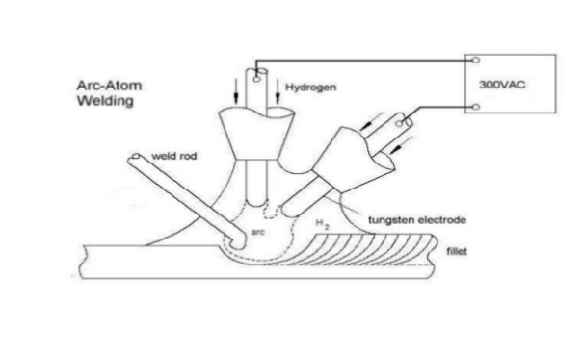
- The atomic hydrogen come out from arc fan and at atmospheric conditions it is unstable gas. Therefore, it is reunited to form the molecular hydrogen which is exothermic reaction so that heat generated due to this will be used for melting and joining of plate.
- In addition, out of the molecular hydrogen produced about 1/3rd of is getting burned by taking the oxygen from atmosphere and remaining 2/3rd of is simply moving away form the weling zone acting as a shielding gas for protecting the weld pool form atmospheric contamination.
- From the above point, the heat required for melting and joining of plate is obtained form exothermic reaction and by burning of 1/3rd of hydrogen. Due to this average temperature of process $T_{avg}=2000 to 2500 °C$.
- After the invention of atomic hydrogen gas welding the oxy-hydrogen welding become obsolete.
Application: This method can be used for joining of both low and high melting point temperature of reactive metals such as aluminium, magnesium etc. In addition to reactive metals, the process also can be used for joining of stainless-steel components.
ARC WELDING:
- When the heat required for melting and joining of plates is obtained due to electrical arc when it is called as arc welding operation.  - When the power supply is given and optimum gap is maintained between the tip of electrode and the work piece, the arc or arc fan is produced between them.  - When the power supply is given and optimum gap is maintained between cathode and anode then very high velocity negatively charged electrons generated at cathode attracted by anode and moving towards anode. | 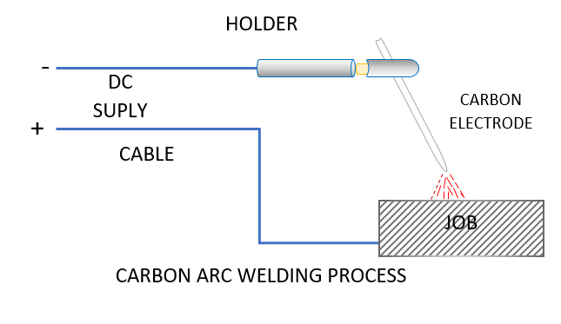
- When this high velocity electrons are impinging on the anode, the KE of electrons will be converted into heat energy therefore heat is generated at anode.
- Simultaneously high velocity positively charged ions will be generated at the anode, attracted by the cathode and moving towards the cathode.
- When this high velocity ions are impinging onto the cathode, the KE of ions will be converted into heat therefore heat is generated at the cathode.
- Because velocity of electrons is very much higher than the positive ions, the heat generated at the anode is very much higher than the cathode. E.g. Heat Generated At $Anode: Cathode = 2:1$
- When the electrons and ions are moving in the opposite directions some of the electrons and ions get collided in between. So that the KE possessed by both elements is converted into heat energy spontaneously and it is observed as a spark.
- When such a spark is produced continuously then it is observed as arc, the temperature induced is very high which is about $5000 to 6000°C$
- At the spark zone the ultra-violate rays will be generated and moving around. If the arc welding operation is seen by the human eye directly, the ultra-violate rays are impinging onto the human eyes starts paining immediately. To avoid this problem, arc welding must be seen only through safety goggles.

DIRECT CURRENT STRAIGHT POLARITY/ ELECTRODE NEGATIVE (DCSP/ DCEN):  - Heat generated at workpiece to electrode is 2:1.  - Because of higher heat generated at the work piece, higher melting point metals and higher thickness plates can be joined easily and depth of penetration is also higher.  - Whereas due to low heat generated at the electrode, melting rate of electrode is low and only low speed is possible. | 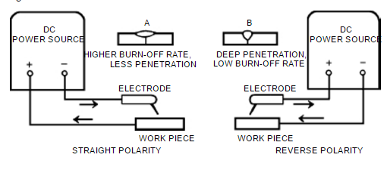
DIRECT CURRENT REVERSED POLARITY/ ELECTRODE POSITIVE (DCRP/ DCEP):  - Heat generated at workpiece to electrode is 1:2.  - In DCRP, because of lower heat generated at the work piece, only melting point and lower thickness plates can be welded and depth of penetration is also low.  - Whereas due to high heat generated at the electrode, melting rate of electrode is high and deposition rate is high and welding speed is also high. | 

ALTERNATING CURRENT HIGH FREQUENCY (ACHF):  - Heat generated at the workpiece and electrode will become equal. E.g. heat generated [W: E] =1:1  - In ACHF, the heat generation is 50-50 between workpiece and electrode, only medium melting point and medium thickness plates can be welded and depth of penetration is also medium.  - Whereas due to medium heat generated at the electrode, melting rate of electrode is medium, deposition rate is medium and welding speed is also medium. | 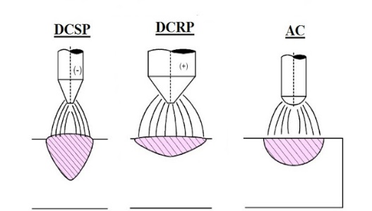  DEPTH OF PENETRATION
DEPTH OF PENETRATION: Depth of penetration is the depth to which the base metal and filler material have to melted and mixed during welding process.
ARC RECOVERY TIME:
- Time taken for establishing the arc between the tip of electrode and work piece is called arc recovery time.
- Generation time depends on the voltage of power supply. E.g. as voltage is increasing the generation time reducing.
- Travelling time is the distance travelled by electrons and ions between anode and cathode.
- For better AC arc Welding operation ART should be minimum as possible.
$$Arc Recovery Time \left(ART\right)= Generation Time \left(GT\right)+ Travelling Time \left(TT\right)≤{Cycle Time \left(CT\right)}/2$$
- Between ART and CT it is always recommended to reduce ART only. As voltage increases ART reduces but it may give electrical shock to welder. To avoid this, the range of voltage used in the arc welding is from 30 to 70V.
EQUILIBRIUM CONDITION FOR WELDING:
- For keeping the welding process under stable equilibrium conditions, whatever the energy supplied by the power supply unit must be supplied to the arc point.
- The energy given by power supply in controlled by carrying out the voltage and current setting whereas energy utilized at the arc point is controlled by changing the arc length.
- Therefore, it is required to determine setting of optimum power source and optimum arc length. So that during welding it is required to set the weld equipment for optimum voltage and optimum current.
$V_{o}=$ Open Circuit voltage/ Maximum Voltage in secondary winding/ Actual EMF generated in the secondary winding of transformer | $I_{s}=$ Short Circuit current/ Maximum current passing through the circuit
$V_{a}=$ Arc Voltage | $ρ=$ Resistivity
$R_{s}=$ Resistance in Secondary Winding $={V_{o}}/{I_{s}}$ | $L=$ Spark Gap
$E_{P}=$ Energy Supplied by power source | $A=$ C/S area of wire,
$E_{a}=$ Energy Utilised at arc point | $V_{P}=$ Voltage in Power Source
To develop arc, Voltage in circuit $V<V_{o}$, Current in circuit $I<I_{s}$
- Arc Characteristics: It’s Plot between arc voltage and Arc Length.
$$V=a+bL$$  Where $a,b=$ Constant, $L=$ Spark gap. | $$R=ρ\frac{L}{A}∝L$$ | $$V_{a}=a+bL$$ | $$V_{a}=R_{air}I∝L$$
- V-I / Linear Power Source Characteristics:
At Equilibrium Condition,  $$E_{P}=E_{a}=V_{1}I_{1}(V_{1}I_{1} is the point on the straight line From the graph)$$  Equation of Straight Line, $$\frac{I}{I_{s}}+\frac{V_{P}}{V_{o}}=1⇒V_{P}=V_{o}\left(1-\frac{I}{I_{s}}\right)$$ For Stable equilibrium condition, $V_{P}=V_{a}$ $$I=\frac{I_{s}}{V_{o}}\left(V_{o}-a-bL\right)$$  $$Power P= IV_{a}$$ For Optimum Power, $\frac{dP}{dL}=0$  We can find optimum values of all parameters at optimum spark gap. | 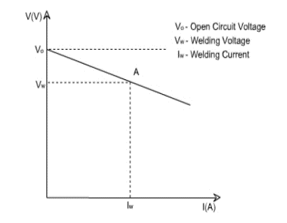
DUTY CYCLE (DC): The percentage of time during which the machine can be operated (arc is on) without overheating the vital elements of welding equipment.
- Arc On time (AOT) is the time during which the arc is on or actual welding operation is carried out.
- Rest Time is time during which total welding equipment is switched off.
If $Q_{g}≤Q_{d}$, No rest Required.  If $Q_{g}>Q_{d}$, Rest Required. | During AOT,  $$Q_{g}=VI=I^{2}R$$ $$Q_{d}=hA∆T$$ | During RT,  $$Q_{g}=0$$ $$Q_{d}=hA∆T$$

$$Rate of Accumulation Q_{a}=Q_{g}-Q_{d}$$ |  | $$Max. Allowable Accumulation=Q_{a max}$$
$$AOT=\frac{Q_{a max}}{Q_{a}}$$ | $$RT=\frac{Q_{a max}}{Q_{d}}$$ |  | $$DC=\frac{AOT}{TWT}=\frac{AOT}{AOT+RT}$$
RATED AND DESIRED:
$$I_{r}^{2}D_{r}=I_{d}^{2}D_{d}$$ | $D_{r}=$ Rated Duty Cycle,  $I_{r}=$ Rated Current, | $D_{d}=$ Desired Duty Cycle,  $I_{d}=$ Desired Current,
ELECTRODES:
- It’s acting as an electrical element for closing the electrical circuit.
- Sometimes, it’s melting and supplying additional molten metal to the weld bead or joint.
TYPES OF ELECTRODES
CONSUMABLE |  | NON-CONSUMABLE
BARE WIRE | COATED | It should have high electrical conductivity.  And high melting point. E.g. W, C, Graphite
E.g. Brass, Low/ Medium Carbon Steel
ADVANTAGES OF COATING GIVEN ON ELECTRODE:
- It can deoxidize the melt.  - It can absorb the gases present in the molten metal.  - It can form slag layer over the weld bead for protecting the weld bead from atmospheric contamination. | - It can stabilize the arc.  - It can produce shielding gases.  - It can supply the alloying element.
Ferrosilicon or Ferro manganese Coating- 1,2 | Rutile Coating ($TiO_{2}$)- 3
Potassium Silicate- 4 | Cellulose Coating- 5
Al, Cu, Ni, Mn, Mo, Etc- 6
DAMPED ELECTRODE:
For joining of highly reactive metals, high cellulose coatings are given on the electrode is called damped electrode.
$$\frac{Volume}{Electrode}=\frac{π}{4} d^{2}L_{e}$$ | $L_{t}=$ Total Length of Electrode,  $L_{e}=$ Effective Length of Electrode, | $L_{s}=$ Stub/ Holding Length of Electrode,  $d=$ Diameter of Electrode,
DESIGN OF WELD BEAD:
- Root gap: The gap provided between the two plates to be joined at the bottom most point of weld bead. $Root Gap≤4 mm \&≠0$  - Land: The straight portion of plate provided at the bottom of weld bead without any joint preparation. $Land≤5 mm$  - V-Angle: Whenever the thickness of the plate to be joined is greater than 5mm, it is necessary to prepare some type of joint like U, V, J out of which, V- Joint ($60°,30°,90°$) is most commonly used. | 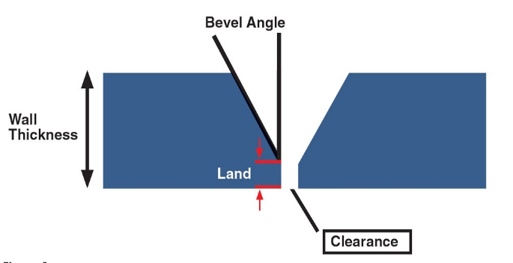
- No. of passes: Whenever the thickness of plates to be joined is larger, it is not possible to joint the plate is a single pass (Sinlge line of weld).
- Crowining or Reinforcement: It’s the extra material provided over and above the surface of plate. Crowning is provided to ensure thath resistance available at he joint must be equal to resistance available at plates.
- Spatter: During welding operation due to force of arc or flame some of molten metal particles are jumping from the weld pool and falling on the outer area of the plate.
$$Crowning Volume = 10 to 15\% of Volume of weld bead$$ | $$Spatter = 5 to 10\% Vol. of Weld bead$$

$$\begin{matrix}Total No of Electrod \\ Requried for Welding\end{matrix}=\frac{Tot. Vol. of Weld bead}{Vol. of 1 Electrod}$$ |  |  | $$\begin{matrix}Tot. Vol. of \\ Weld bead\end{matrix}=\begin{matrix}Vol. of \\ Weld bead\end{matrix}+Crowning+Spatter$$
3D Heat Loss:  $$Q=\frac{5}{4}πKT_{m}W\left[\frac{2}{5}+\frac{VW}{4α}\right]$$ | 2D Heat Loss:  $$Q=8KT_{m}t\left[\frac{1}{5}+\frac{VW}{4α}\right]$$ |  |  | $Q=$ Heat Supplied rate by welding process = Heat is utilized for melting + heat transfer by conduction
$V=$ Welding Speed | $W=$ Width of Plate |  | $T_{m}=$ MPT-RT |  |  | $α=$ Heat diffusivity
$$\begin{matrix}No. of Electrod \\ Requried Per Pass\end{matrix}=\frac{Length of Weld bead}{Lengh welded by one electrode}$$ |  |  | $$No. of Passes=\frac{Total No of Electrod Reqired}{No. of Electrod Per Pass}$$
$$\frac{AOT}{Pass}=\frac{Length of Welad Bead}{Welding Speed (V)}$$ |  | $$Tot. AOT=\frac{AOT}{Pass} \left(No. of Passes\right)$$ |  |  | $$TWT=\frac{Tot. AOT}{D.C.}$$
MAGNETIC ARC BLOW: The magnetic force created by electric current will deflect the arc and welding takes place at different place than the required called as Magnetic Arc Blow or Arc Blow.
- When electrons flow through a conductor, they produce lines of magnetic force that circles around the line of flow in perpendicular planes.
- The lines of magnetic force are called magnetic flux lines. These lines move easily in metal but not in air.
- As the electric current increases the magnetic arc blow also increases.
- By using potassium compound coating on the electrode, it is possible to restrict the polling of the arc up to certain limit.
Reasons for magnetic arc blow:  - Welding near to the earth connection.  - Starting and ending arc blow due to non-uniform metal presence.  - Multiple electrode welding operation with different current condition. | Remedies:  - Welding away from earth connection.  - By providing additional plates such as start on and run out plate.  - Same current conditions for all the electrodes  - Use AC power source instead of DC supply.
- TUNGSTEN INERT GAS (TIG/ AAW/ GTAW) WELDING:
Electrode: Tungsten Electrode (Non consumable) is used due to it’s high melting point ($3300°C$)  Argon Arc Welding: Argon/ Argon +Helium is used as inert Gas.  Inert Gas Supply: It works as shielding Gas.  Diffusion of tungsten atoms: Due to high heat, some tungsten atoms enters in weld pool. To keep dissipate heat, cooling system is used.  Joining the reactive metals: Due to Shielding Gas, it can be used for highly reactive material welding.  After the invention of TIG, Atomic Hydrogen welding become obsolete. |  | 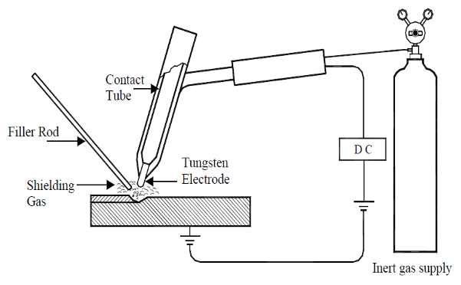
Limitations of TIG:
- Cost of TIG welding is high.  - Can be used for joining of plates up to 5mm thickness. | - The additional filler rod must be used.  - Brittleness of weld bead is increasing due to sudden Cooling of high temperature material.
- METAL INERT GAS (MIG) WELDING:
Electrode: Metallic consumable Electrode is used. So, No cooling required.  Melting of electrode and supplying arrangement of filler metal (Reel) is here.  Inert Gas Supply: It works as shielding Gas. Argon/ Argon +Helium is used as inert Gas.  Use for joining of the reactive metals like aluminium, magnesium etc…  For easy winding of electrode, the maximum size of electrode is 3 to 5 mm.  Advantages:  - Cost of MIG welding becomes less than TIG welding.  - Above 5 mm thickness plate can be welded directly.  - Rubber pads are used to remove the surface impurities form electrodes.  - The diffusion of tungsten is eliminated completely. | 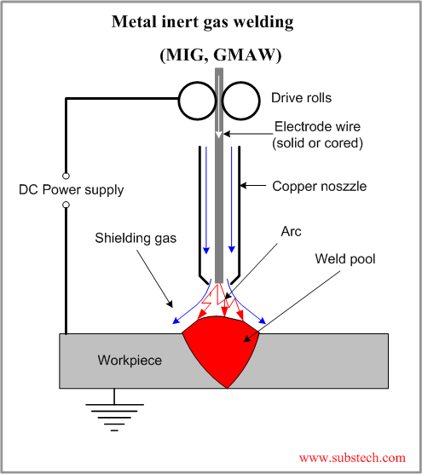
Disadvantages:
- Welding speed used is low. It used for plate thickness $<$ 30mm only. For plate thickness $≥$ 30mm, Spatter loss increases.
- Size of the weld pool produced in fromt of the arc will be larger for lower welding speed.
- Spatter loss becomes grater than 10% at low speed.
- SUBMERGE ARC WELDING (SAW):
- Arc is submerged during welding.  - In place of inert gas large quantity of flux powder is used through hopper. And metallic consumable electrode (2 to 8 mm) is used.  - Slug formation is due to melting of granular flux.  - Because of usage of large quantity of flux powder, the weld pool is completely covered by flux powder. Unused Flux powder can be reuse.  - The flux powder present on the weld pool may contain air particle.  Advantages: Spatter loss is minimum and higher thickness plate can be welded in single pass welding.  Disadvantages:  - As the thickness of the plate is increasing the quantity of flux powder required also increases and the cost of welding increases.  - Due to this maximum thickness plate welded in single pass submerged arc welding is up to 75 mm economically. |  |  | 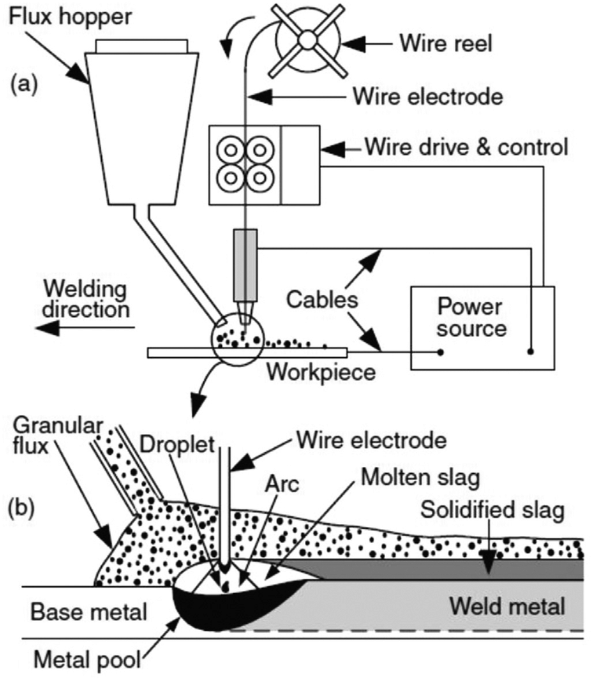
Plate thickness | $≤5mm$ in TIG | $≤30mm$ in MIG |  | $≤75mm$ in SAW
- ELECTRO SLAG WELDING (ESW):
- It’s Arc and Resistance Welding.  - Electrically conducting flux powder: Due to Electrical resistance of this electrically conducting flux powder heat is generated. This heat is used to create welding pool.  - This Slag/ Flux has lower density than the molten metal so it will be always above the molten metal.  - Water Cooled Copper Cover: It’s used to support the molten metal and slag. It dissipates heat from the molten welding bead/ pool for solidification.  - It’s economical when plate thickness is greater than 75 mm. | 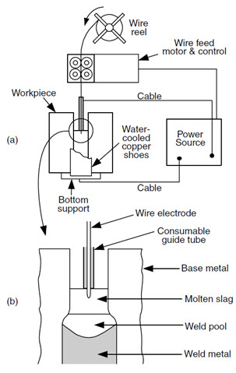
HEAT INPUT: (Most IMP)
$$\begin{matrix}Power Delivered \\ or Power Availabe\end{matrix} P (in W)=VI$$ | $$\begin{matrix}Heat input per unit time \\ or Energy Req. per unit time\end{matrix}=\frac{H(in J)}{t(in s)}$$
$$\begin{matrix}Process Efficiency \\ or Heat Transfer Efficiency\end{matrix} η=\frac{H/t}{VI}$$ | $$Heat input per unit length \frac{H}{l}=\frac{η VI}{v}$$
$v=$ Welding Speed | $l=$ Welding Length
$$H\left(in J\right)=u*Volume=u Al⇒v=\frac{η VI}{u A}$$ | $u=$ Specific Melting energy or Energy Required to melt per unit volume
$$Melting Efficiency, η_{m}=\frac{Heat Reauired for melting}{Net Heat Supplied}=\frac{v uA}{η VI}$$
$η$ indicates not all the available energy converted into melting.
THERMITE WELDING:
It’s a chemical welding process in which, heat required for melting and joining of plate is obtained dur to exothermic chemical reaction. ${Fe}_{2}O_{3}+2Al⟶2Fe+{Al}_{2}O_{3}+Heat$, Where Thermite Mixture ${Fe}_{2}O_{3}+2Al$, Slag: ${Al}_{2}O_{3}$
- Just by mixing iron oxide and aluminium powder the chemical reaction does not takes place. Ignition powder is added in the mixture for easy ignition. E.g. Mg, Barium Peroxide.
- By using the match box, the ignition for burning the thermite mixture will be given.
- The maximum temperature Produced in this method is $3750°C to 4000°C$ and average temperature is around $2500°C$.
Application: It used to join the railway tracks.

- SPOT WELDING: The amount of current to be passed through the circuit depends on the thickness of plates to be joined and melting point of metal to be joined.
Method to determining current passing through the electric circuit:
- Steel plates having varying thickness: $Heat Generated∝I^{2}∝Thickness (∵R=ρl/A)$
- Two different plates having same thickness:$Heat Generated∝I^{2}∝Melting Point$
- Two different material plates having different thickness:$Heat Generated∝I^{2}∝Thickness*Melting Point$
TOTAL RESISTANCE OF ELECTRIC CIRCUIT:
- Electrical Resistance of electrode material. $R_{1}$ Keep as minimum as possible.
- Contact resistance between the tip of the electrode and workpiece.$R_{2}$ Keep as minimum as possible.
- Electrical resistance of the plate to be joined. $R_{3}$ is constant.
- Resistance between joining of surface of contact. $R_{4}$ Keep as maximum as possible.
TIME AND TEMPERATURE: $Spot welding time≤0.2 s, T_{max}=9000 °C to 12000 °C$
FORCE VS TIME GRAPH IN RESISTANCE WELDING OPERATION:
SQUEEZE TIME: Time during which air present on the surface will be squeezed out or driven out.  WELD TIME: Time during which current is actually passing through the circuit.  HOLD TIME: Time during which the force applied on plates is continued to maintain until the molten metal will get solidify and withdraw the load afterwards.  OFF TIME: Time during which the total resistance welding equipment is switched off. Off time is required for,  Shifting of electrodes Rest time | 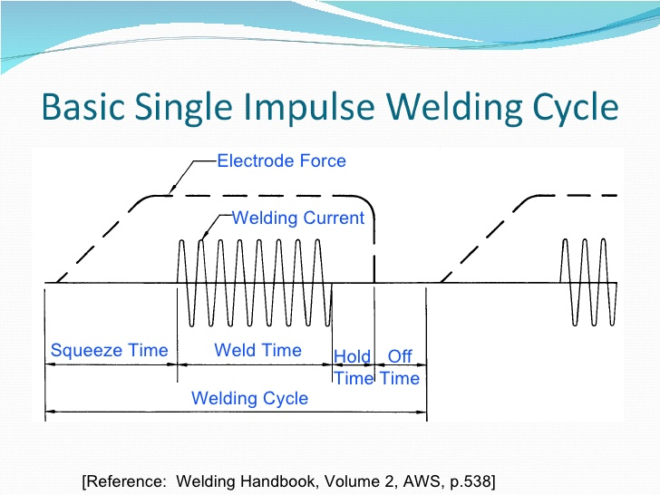
MODIFICATION IN RESISTANCE WELDING:
The modifications suggested to improve efficiency of resistance welding cycle,
- During weld time, the force applied on the plates is reduced slightly so that the surface roughness of the contacting surface is trying to regain the resistance, hence R4 is increasing and heat generation is increasing so that nugget size increasing.
- Before reducing the force in the hold time, one or two cycles of power supply will be given again so that the heat generated due to this is used for post heating of the weld bead due to this internal residual stress will be relieved, brittleness will be reducing and toughness will be increased.
HEAT UTILIZED/ REQUIRED/ USED TO PRODUCE NUGGET: Most imp
$$HG (in J)=VIτ$$ | $$HG \left(in W\right)=VI$$ | $$η={HU}/{HG}$$ |  | Heat Dissipation, $HD=HG-u$
$$HU (in J)=m\left[SH+LH\right]$$ |  |  | $$HU \left(in J\right)=ρ∀\left[C_{P}\left(T_{m}-T_{r}\right)+LH\right]$$
$$HU \left(in J\right)=ρ∀\left[LH\right]=∀u$$ |  |  | $$HU \left(in W\right)=Av u$$
For Resistance Welding, $η=85 to 95\%$ |  |  | For Arc Welding, $η=45 to 45\%$
For Gas Welding, $η=55 to 65\%$ |  |  | For Thermite Welding, $η=85 to 95\%$
VOLUME OF NUGGET:
The volume of elliptical nugget is assumed to be equal to volume of Cylindrical nugget forming between two electrode tips with diameter equal to diameter of top of electrode and height equal to distance between two electrode tips. | The volume of elliptical nugget is assumed to be equal to volume of Spherical nugget forming between two electrode tips with diameter equal to diameter of top of electrode and height equal to distance between two electrode tips.
METHODS OF IMPROVING THE STRENGTH:
Method-I: By ensuring the major axis of elliptical nugget is coinciding with axis of joint formation. The shifting of major axis of elliptical nugget may happen when the total resistance above the joint is not equal to the total resistance below the joint.
Solution: The resistance $R_{1}$ can be changed by:  - By changing the material of the electrode.  - By changing the dimensions of electrodes. | Unequal Resistance is due to,  Same material different thickness Different material Same thickness Both are different
Diameter of electrode Consider, $D≥6\sqrt{Thickness}$ to maintain resistance as per $R=ρl/A=4ρl/{\left(πD^{2}\right)}$
Method-II: Making more than one resistance weld nugget between the plate.
Solution: To avoid Shunting or By passing of electricity minimum distance between to spot weld is taken as $48t$.
Method-III: Making Continuous Resistance weld bead between the plates to be joint.

- RESISTANCE SEAM WELDING (RSW):  - Whenever the continuous resistance weld bead is to be produced between the two plates to be joined is called RSW.  - The shunting problem is more severe because the continuous material is available very nearby and it is not possible to maintain the distance. Hence higher current is supplied.  - PROJECTION WELDING: The method of joining the projected component onto a flat component by using the resistance spot welding operation is called resistance projection welding. In this method, the shape of electrode must remain same as the components to be joined.  - PERCUSSION WELDING: No Electrode + No fusion + Pressure  - In this method, first the power supply will be given such that heat is generated at the joint is enough to rise temperature nearly equal to but less than melting point temperature of metal.  - Therefore, stop the power supply and apply the force percussively (Suddenly) so that surface atoms are sharing the energy producing the surface alloy joint.  - When the joint is heated near to melting point temperature then material present at the joint is very soft and ductile. So that is due to application of percussive force that soft material is projecting out producing the projection at the joint called as flash. Hence, this method is also called as flash butt welding.  - In this method, no separate electrodes are used, but the components to be joined them selves are acting as electrodes.  - This joint is for joining of the shafts end to end. | 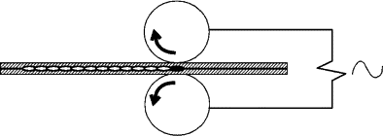RSW 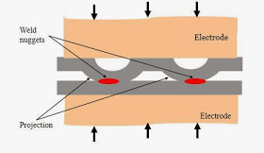Projection Welding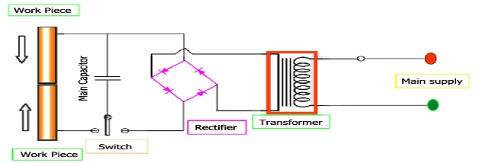  Percussion Welding
APPLICATION OF RESISTANCE WELDING:
- Whenever increase in weight of system is not allowed due to joining process, in such cases resistance welding will be used. E.g. Aircraft Industry.
- Whenever the leak Proof joints are to be produced. E.g. Joining of fuel tank to automobile body, Manufacturing of pressure vessels etc.
- Used for joining throw-away type of tip of tools to tool bodies etc.
SOLDERING, BRAZING AND BRAZE WELDING: Wetting + Surface Alloy Joint
Wetting means ability of a liquid to maintain contact with a solid surface.
- These methods are considered as Non-Fusion and Non-Pressure Welding methods.
- In all the non-fusion operations, the molten of fuller rod is filled over the joining plates so that it is getting wet on to the surface of joining plates.
- During process of solidification, the filler rod material and parent material will share the energy and produces a metallurgical bond that is surface alloy joint.
- Based on the above mechanism by which joint formation is taking place is wetting & surface alloying.
- Strength of surface alloy joint is lesser than fusion welds.
REASONS FOR DEVELOPMENT OF NON-FUSION WELDING OPERATION:
- Two different metals are to be joint.
- Very thin component is to be joined to a very thick component.
- Some metals can never produce the liquid molten metal. E.g. Tungsten converts to powder at $3400°C$
- To change the mechanical properties of parent material which is not allowed in some cases.
SOLDERING:
Mechanism | Wetting and surface Alloying
Temperature of Joints | - Temperature must be less than the melting point temperature of plate metal.  - Temperature should be less than $427°C$. Because of evaporation of Tin.
Heat Source | Electrical Resistance Heating (Soldering iron) | Air Acetylene Flame
Filler Rods | Soft Soldering: Lead-Tin Alloy (50-50) | Hard Soldering: Lead-Tin Silver Alloy (30-30-40)
Application: It’s used for joining electronic wire to the printed circuit board and used for joining metals whose melting point temperature is less than $427°C$.

BRAZING AND BRAZE WELDING:
BRAZING: Joining of two components without any joint preparation is called as Brazing operation.
BRAZE WELDING: Joining of two components with joint preparation is called as Braze Welding operation.
Mechanism | Wetting and surface Alloying
Temperature of Joints | - Less than melting point temperature of metals.  - Greater than $427°C$.  - Whenever the melting point of metal is less than $427°C$ it can’t be brazed or braze welding but it can be soldered.
Heat Source | Electrical Resistance Heating (Soldering iron) | Air Acetylene Flame
Filler Rods | - In Brazing, because of no joint is prepared, the flow of molten metal into the joint is taking due to capillary action.  - Copper-Zinc alloy is found to have highest capillary action. Hence, it is used as filler rod in brazing. | - In case of Braze Welding because of open joint the flow of molten metal into the joint is due to the gravity force.  - Possible high-density material used as a filler rod is Copper-Tin alloy. Hence, it is used as a filler rod in braze welding.
Application | - A crack present in cast iron is repaired by using brazing operation because joint preparation is not possible.  - Two cast-iron pipes to be joined along the length by using braze welding because joint preparation possible.
Examples | - Other examples of brazing are joining of copper pipes in refrigerator or air conditioning unit, repairing the cracks present in stainless steel utensil, joining of baffles to an automobile radiator.  - Other examples of Braze welding are joining of two large size electrical cable, joining of fin to IC engine cylinder etc…
GAP BETWEEN INCREASING IN CASE OF BRAZING: $Optimum Gap:0.0125≤Joint Gap≤0.0625mm$
- At the beginning as the joint gap is increasing, the flow of molten metal in the joint becomes easier. Therefore, wetting and surface alloying area is increasing and strength of the joint is increasing.
- After some gap, the amount of filler rod material present at the joint becomes considerable so that during usage when the force is applied it is first transmitted to surface alloy joint and then transmitted on to the filler rod material.
- Hence, the joint failure takes place due to failure of filler rod material. Hence, the strength of the joint reduces.
PRE-HEATING AND POST-HEATING OF WELDING PROCESS:
PRE-HEATING: Heating the joint or total plate before the actual welding.  REASONS FOR PRE-HEATING:  - To evaporate or remove the dirtiness present at the joint.  - For increasing the welding speed.  - For Joining of high thermal conductivity and high melting point metals.  - During joining of high coefficient of thermal expansion material.  - During joining of ring like structure. | POST-HEATING: Heating the joint or total plate after the actual welding.  REASONS FOR POST-HEATING:  - Relieving internal residual stresses present in the weld bead.  - Reducing the brittleness.  - Increasing ductility and toughness.  - Converting Martensite structure into Troosite or Sorbate structure.
WELDABILITY OF METALS: The ease (Simplicity) with which welding of a given material can be done without producing any defects is called as weldability.
FACTORS INFLUENCING THE WELDABILITY OF METALS:
- Melting point of metals.  - Thermal Conductivity of Metals. E.g. Cast iron is difficult to weld.  - Coefficient of linear thermal expansion. | - Reactivity of metals.  - Electrical Resistance.  - Surface Condition.
The metal which is influenced by maximum number of factors is considered as very difficult to weld metal whereas the metal which is influenced by minimum number of factors are considered as easy to weld.

EXTERNAL DEFECTS PRODUCED IN WELDING OPERATIONS:
These are the defects which present at the surface of weld bead,
- Overcut:  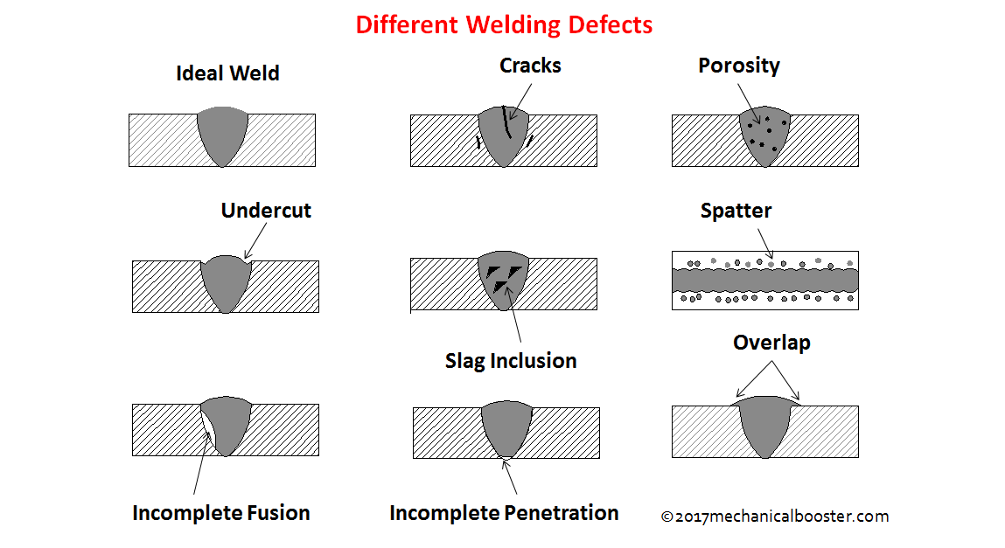 | - Using DCRP with magnetic arc blow.  - Excessive current conditions.  - Oversize of the electrodes.  - Uses of modified movement of torch with filler rod.
- Under Cut   | - Use of DCSP with magnetic arc blow.  - Excessive arc Length.  - Undersize of Electrodes  - Use of damped Electrodes
- Crater  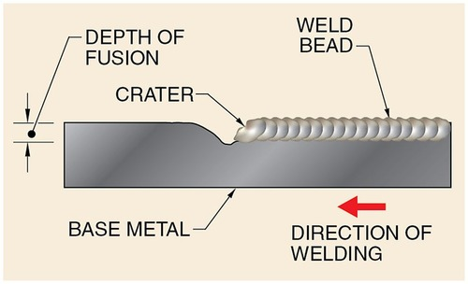 | The shallow spherical cavity produced at the end of weld bead is called Crater. Reason is incorrect torch angle at the end of welding.
- Spatter:  During welding operation due to force of arc or flame some of the molten particles are jumping from the weld pool and falling on the other areas of the plate called as spatter. | Reasons:  - Joining of large thickness plates at low welding speeds.  - Use of damped electrodes.  - Excessive arc length.  - Presence of magnetic arc Blow.  - Modification of torch movement in gas welding | 
- Excessive Convexity: | - Use of low welding speeds with DCRP.  - Excessive current conditions.  - Oversize of the electrodes. | - Excess Concavity:  Opposite to convexity
- Surface Porosity:  Presence of air or gas particles inside or at the surface of the weld bead is called porosity. | - Gas Welding without the use of flux or arc welding with the use of bare wire electrodes.  - Use of damped electrodes: Due to high cellulose coating, porosity is generated.  - Use of shielding gases during welding.  - Joining of dirty surface without preheating. | 
- Surface Cracks:  The discontinuity present in the weld bead is called as cracks. | - High Rigidity of the joint.  - Joint of high expansion metal without preheating.  - Joining of ferrous metals using hydrogen as shielding gas.  - Joining of ferrous metals using damped electrodes. | 
INTERNAL DEFECTS PRODUCED IN WELDING OPERATION:
These are the defects which presents inside the weld bead,
Slag Inclusion: Presence of slag particle inside the weld bead is called as slag inclusion defect.  - Incorrect selection of flux used in welding.  - Use of forehand welding technique.  - Improper cleaning of weld bead in multi passes welding.  - Improper design of the weld bead or joint. | Lack of fusion: This defect takes place mainly due to insufficient heat available at the joint.  - Incorrect torch angle used in gas welding.  - Insufficient current conditions.  - Joining of high melting point and high thermal conductivity metals without preheating.  - Joining of dirty surfaces without preheating.
Incompletely filled groove: Same as lack of fusion but in addition small amount of root fap or larger amount of land are additional reason. |  | 

